|  |
| --- |
|  |
| CSEA Event Management |
| User Guide (Web) |

|  |
| --- |
|  |

Contents

Introduction 2

Logging in 3

Registering yourself. 4

The Homepage 6

Creating an Event 7

Viewing Your Events 9

Viewing Past Events 11

CSEA Committee Info 12

Viewing Your Profile 12

Logging Out 13

About Us: 14

# Introduction

This is a Web-based Application for keeping track of all your upcoming and previously completed events that the CSEA conducts.

CSEA stands for Computer Science and Engineering Association. CSEA was born as a desire on the part of the students of CSE to have their talents recognized. It is a common platform for all the students to improve and exploit their potential to the fullest and to increase awareness regarding new technologies among the fellow IITians.

CSEA has been actively involved in bringing up events which help student community learn and explore. Its services mostly include insight on newer technologies, coding competitions, fun activities, etc

CSEA takes contributions from all CSE students and staff, creating a wide network of knowledge and resources. It conducts many interesting lectures, interactive sessions, workshops and competitions relating directly or indirectly to our course materials.

It also conducts various sports competitions for CSE students, as we all know, we all need some fun once in a while.

‘

# Logging in

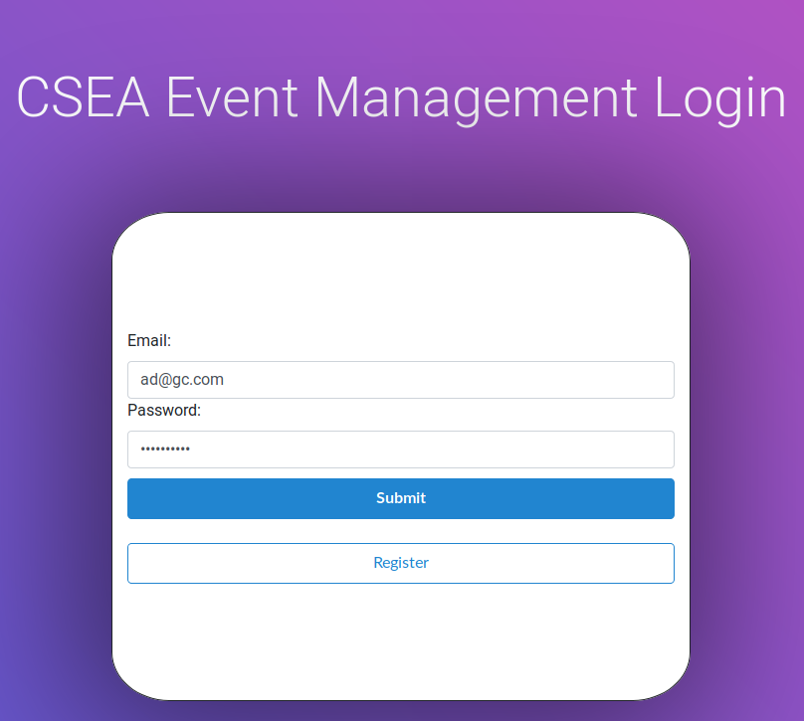

This is the first page you see when you visit the first time.

If you’re a registered user:

* *Email*: You enter your IITG Outlook Email Address. (@iitg.ac.in)
* *Password*: The password that you have chosen when you registered.

If you’re not a registered user, you can read more on how to register here.

# Registering yourself.

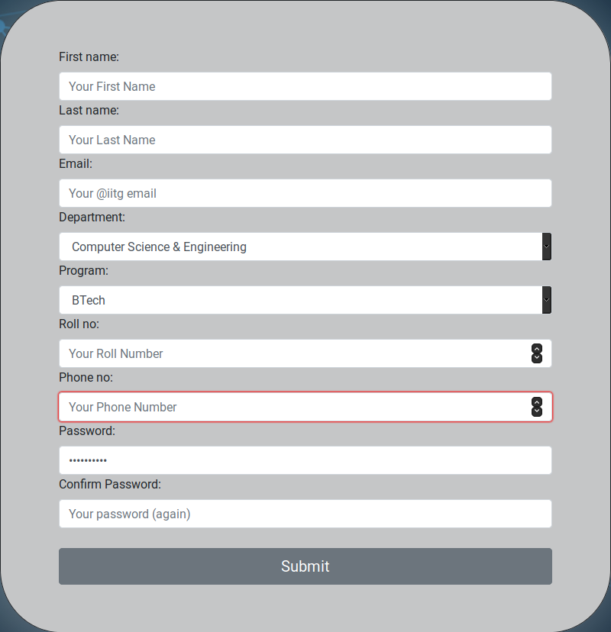

This is the registration page for those who’re not registered users yet. On this page, you enter your details as per the instructions provided in the form.

* *First name*: Your first name.
* *Last name*: Your last name.
* *Email*: We strongly recommend you use the IITG Outlook Email (@iitg.ac.in) provided by the university.
* *Department*: Choose your department from the drop-down list.
* *Program*: Choose your Program (i.e. choose whether you’re in BTech, Mtech, etc) from the drop-down list.
* *Roll no*: Your roll number.
* *Phone no*: Your phone number.
* *Password*: Choose a password.

However, while choosing a password, we strongly suggest you follow these rules:

* Your password shouldn’t be too similar to your other personal information (e.g. your name, your birthday, your license plate number, etc)
* Your password must contain at least 8 characters
* Your passwords shouldn’t be a commonly used password (e.g. qwertyuiop, password, etc)
* Your password can’t be entirely numeric.

# The Homepage

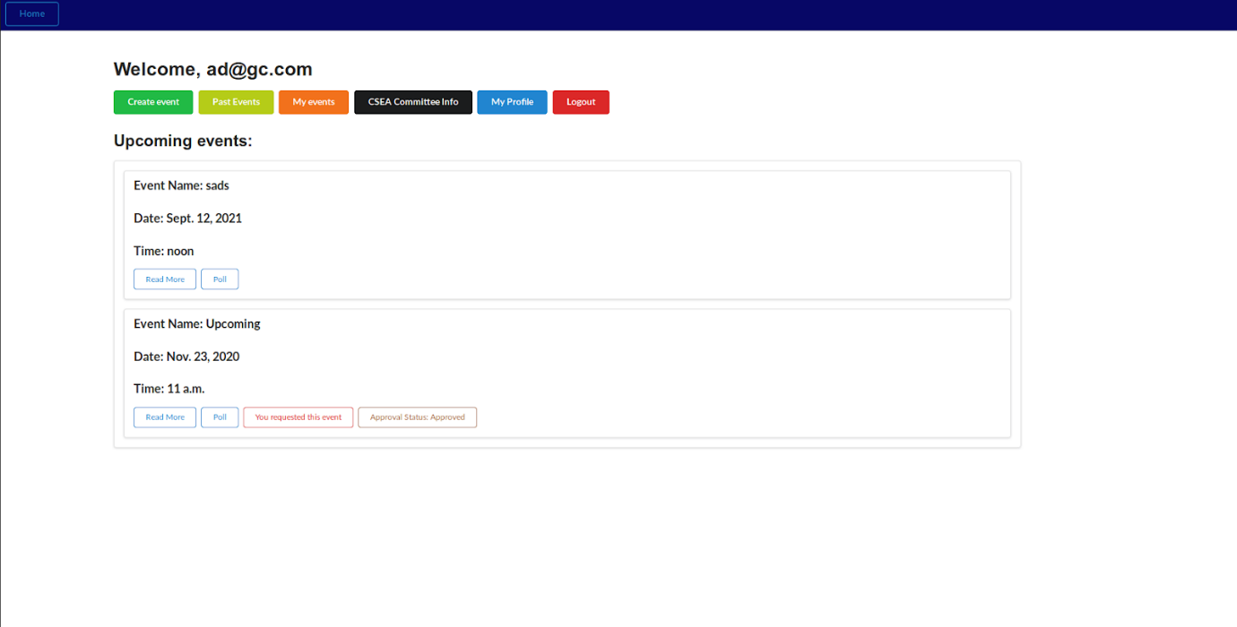

The homepage contains the *Upcoming events*. Each event has:

* *Event Name*: The name of the event.
* *Date*: The date on which the event is planned.
* *Time*: The time of the event on the planned date.
* *Read More*: This shows the following in addition to the name, date and time of the event:
  + *Fee*: The fee to be paid to take part in the event
  + *Contact*: The contact information where you ask queries
  + *Summary*: Brief information about the event.
  + *FAQ*: Frequently Asked Questions, where the answers to usual questions are given
* *Poll*: This shows the number of people that are either planning to attend, planning to not attend, or are unsure about it. You can vote what you are planning to do. You can also click on Modify to change your vote in case you change your mind.
* If you were the one who requested the event to the admin (you can read more on how to create an event here), you’ll be able to see You requested this event.
* In case you were the one who requested the event, you can see the *Approval Status* of your request. If the request has been approved, you will be able to see Approved as the status.

There’s a button called Home on the top left corner on every page on the website which will return you to this page.

# Creating an Event

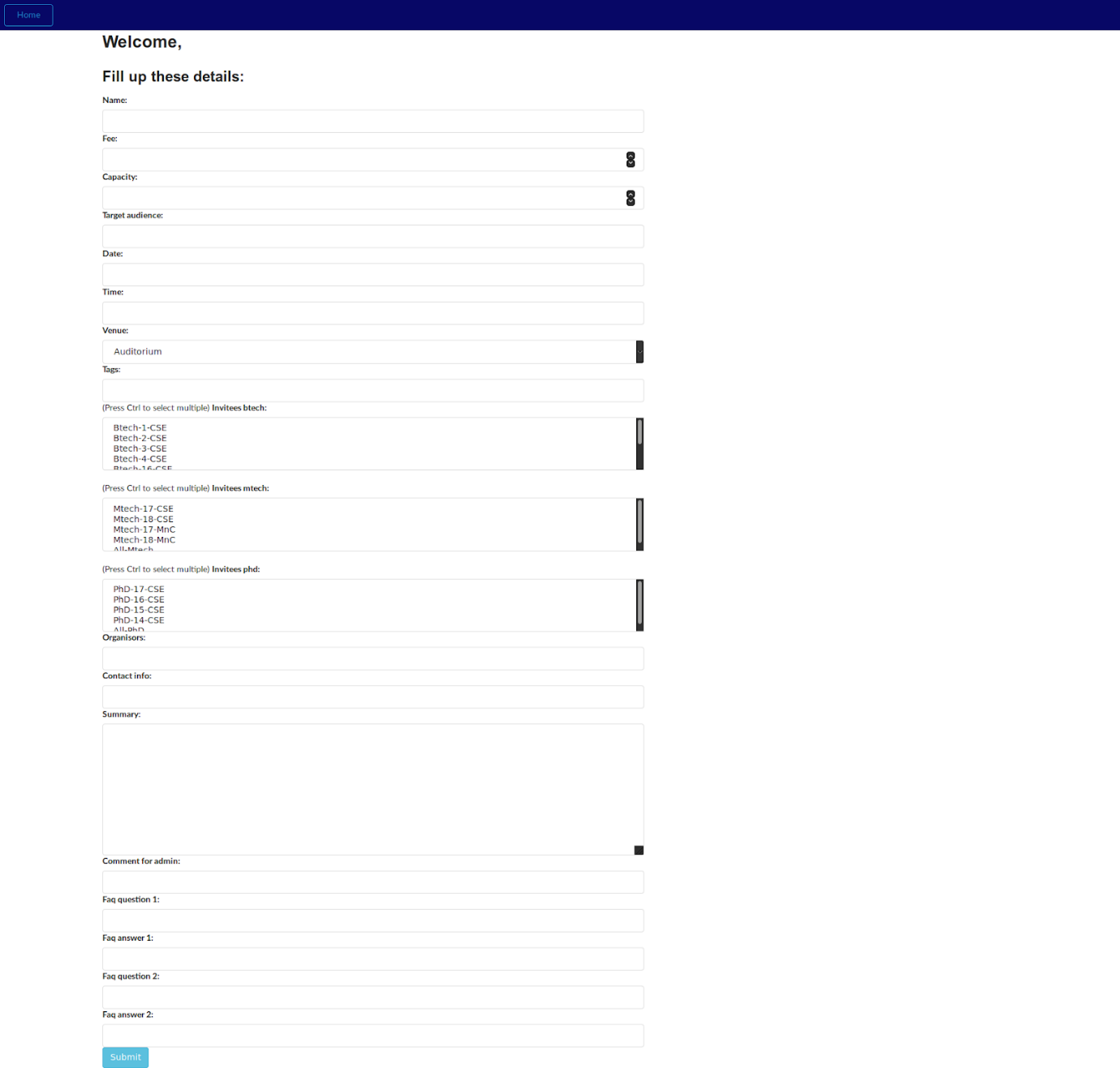

On clicking on Create event button on the homepage, you’ll be greeted with the above screen, which will contain a form where you can enter the information regarding the event you want to create.

* *Name*: Name of the event.
* *Fee*: The fee to be paid to take part in the event.
* *Capacity*: The maximum number of people that can take part in the event
* *Date*: The date on which the event is planned.
* *Time*: The time at which the event is planned.
* *Venue*: Choose the venue from the drop-down list.
* *Tags*: Tags that the event is about, these help in searching, so it is advised to keep all the tags relevant to the event in consideration.
* *Invitees Btech*: Choose which batches from Btech you want to invite. You can select multiple batches by holding down the Ctrl key while selecting them.
* *Invitees Mtech*: Choose which batches from Mtech you want to invite. You can select multiple batches by holding down the Ctrl key while selecting them.
* *Invitees PhD*: Choose which batches from PhD you want to invite. You can select multiple batches by holding down the Ctrl key while selecting them.
* *Organizers*: The people who are the organizers for the event.
* *Contact info*: Contact details for the Organizers, where everyone else can ask in case they have any queries.
* *Summary*: A short detail on what your event is regarding.
* *Comment for admin*: Anything you want to let the admin know. Since your event will be forwarded to the admin for approval, the comment should be relevant and important.
* *FAQ Question/Answers*: You can add the answers to the questions that are usually asked. (You can edit these later, read how to here)

If an event is requested by you, you’ll be able to see You requested this event and the Approval Status. Once the admin approves, the status will be set to approved, and other users will be able to view the event. (As seen in the picture below)

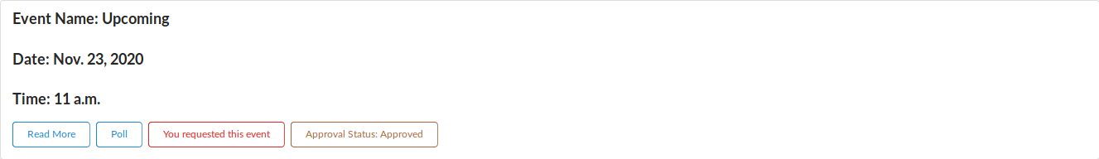

# Viewing Your Events

You can click on the My Events button to show you the events that you have requested.

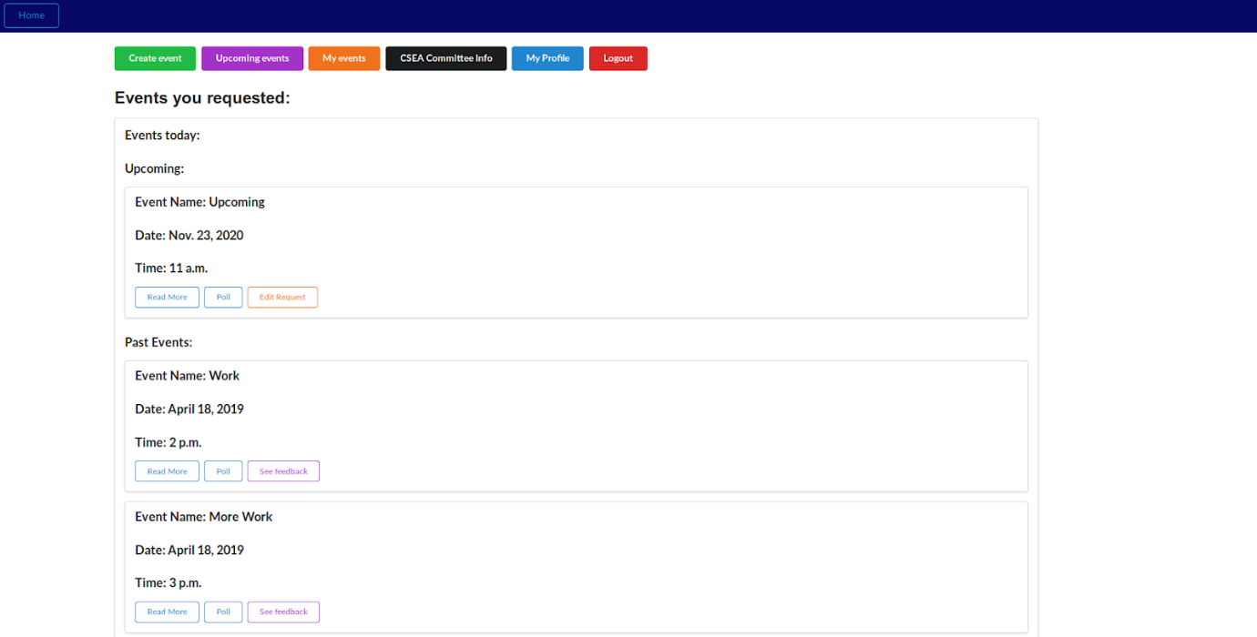

* *Events today*: The events that are happening on the current day
* *Upcoming*: The events that you have planned. You can edit your request to update details or add FAQs.

In case you choose to update the details of the event, you’ll be taken to the following page:

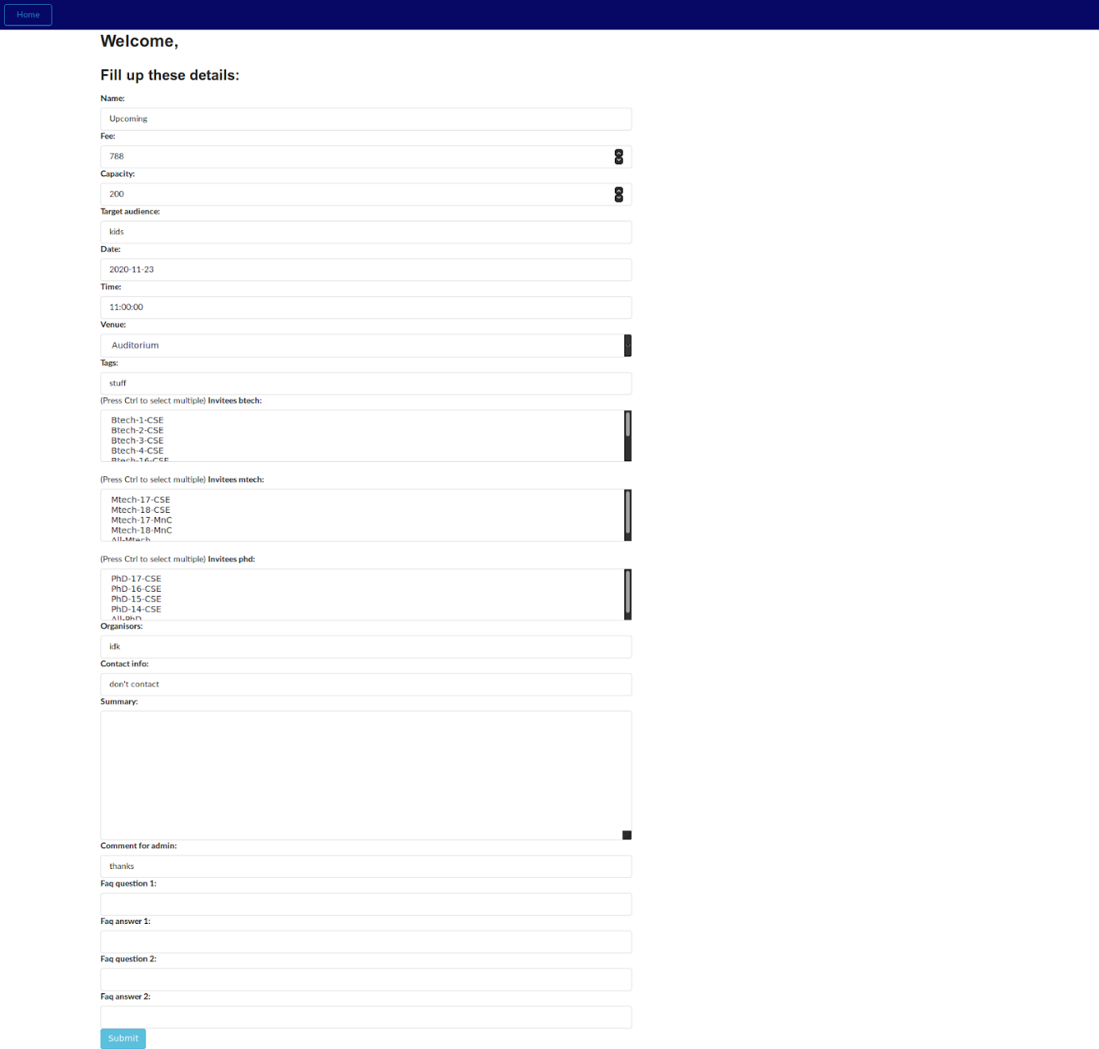

(more on what each field means here)

* *Past Events*: Your events that have been completed. You can See feedback regarding your events and use the feedback to further improve the events you plan

# Viewing Past Events

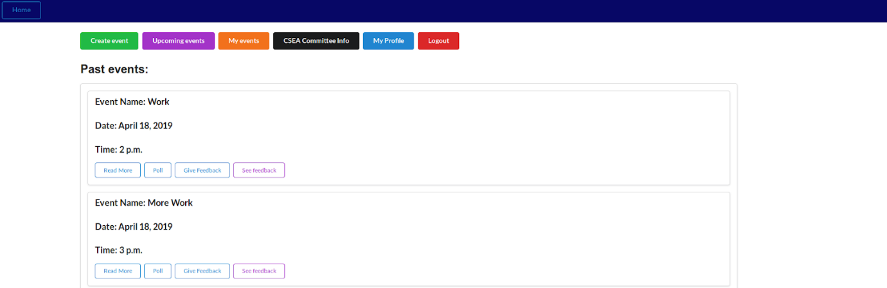

On clicking on Past Events on the homepage, you’ll be shown the events that have been completed.

You’ll be able to provide feedback about an event by clicking on Give feedback. A feedback window has the following fields:

* *Content*: Your feedback. Basically, you can write how the event was, and further you can provide any helpful information or insight that could help us improve the event further.
* *Rating*: You can rate the event out of 10. Higher the rating, the better you felt the event was.

An example is shown below:

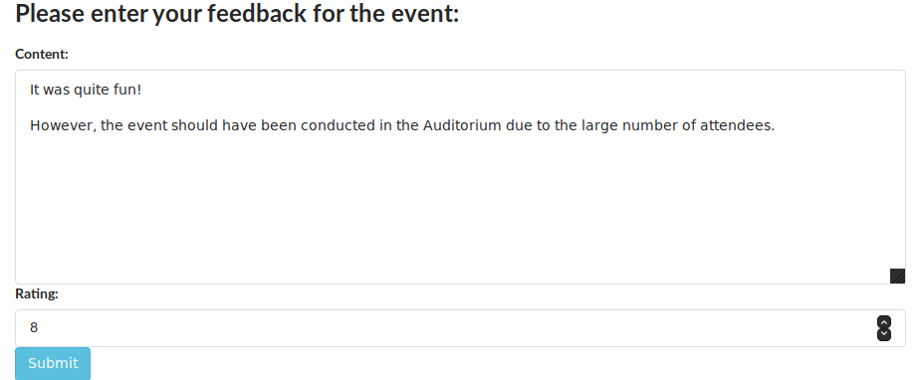

# CSEA Committee Info

Clicking on this button will take you to a page that contains the contact details of the current CSEA Committee. You can contact the committee if you are facing any issues in either creating an event or have any question regarding events, and the organizers are unreachable or unable to resolve your issues.

# Viewing Your Profile

On clicking the My Profile button, you’ll be shown a page containing your profile information.

Here you can change your password. Remember the limitations you have on what you choose your password:

* Your password can’t be too similar to your other personal information
* Your password must contain at least 8 characters
* Your password can’t be a commonly used password
* Your password can’t be entirely numeric

You are reminded of this in the change password page again, and it’s crucial to have a secure password.

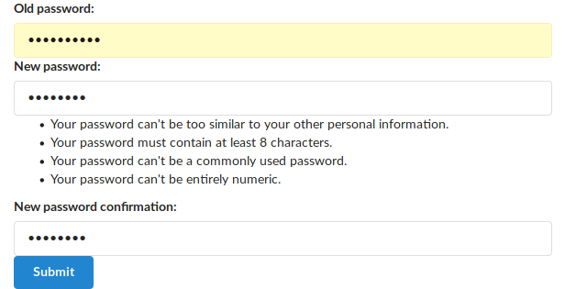

# Logging Out

If for some reason you need to log out, or you’re not on your personal computer, you can log out simply by clicking the red Logout button on the homepage. You’ll be logged out and redirected to the Login Page.

# About Us

Our team has worked really hard to bring you this project. The following people are the ones in developing this website:

* Mayank Chandra
* Lucky
* Rajanala Harshavardhan Reddy
* Partha Pratim Malakar
* Vemuri Sahithya
* Sayalkumar Hajare
* Thahir Mahmood
* Geddam Ikya Venus

We also have an app for Android. The following people worked hard to bring you this app:

* Rohan Nigam
* Rounak Parihar
* Rutvik Ghughal
* Avneet Singh Channa
* Priyanshu Singh
* Siddharth Agrawal
* Geddam Ikya Venus